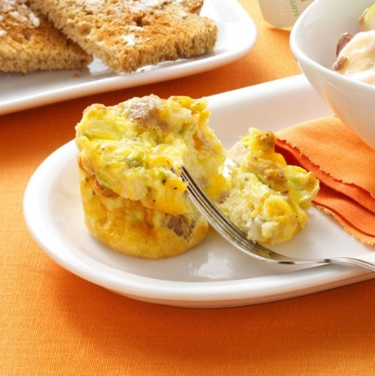
Scrambled Egg Muffins

Ingredients - Yield: 6 muffins
- 1/6 lb (3 Tbsp) turkey sausage (jimmy dean already cooked in red pouch)
- 2 eggs and ¼ cup egg whites
- 1/6 cup (3 Tbsp) chopped onion
- Chopped green pepper
- Dash salt
- Dash garlic powder
- Dash pepper
- 3 Tbsp shredded cheddar cheese

Ingredients - Yield: 12 muffins
- 6 oz turkey sausage (jimmy dean already cooked in red pouch)
- 4 eggs and ½ cup egg whites
- 1/3 cup chopped onion
- Chopped green pepper
- ¼ teaspoon salt
- ¼ teaspoon garlic powder
- ¼ teaspoon pepper
- ½ cup shredded cheddar cheese

Ingredients - Yield: 18 muffins
- 1 package (9oz) turkey sausage (jimmy dean already cooked in red pouch)
- 6 eggs and ¾ cups egg whites
- ½ cup chopped onion
- Chopped green pepper
- ½ teaspoon salt
- ¼ teaspoon garlic powder
- ¼ teaspoon pepper
- ½ cup shredded cheddar cheese

Directions
- In a large bowl, beat eggs. Add the onion, green pepper, salt, garlic powder and pepper. Stir in sausage and cheese.
- Spoon by 1/3 cupfuls into muffin cups coated with cooking spray. Bake at 350 degrees for 20 minutes, convection oven or until a knife inserted near the center comes out clean.

